Appendix S1
Title: Habitat coupling by small fish across lake-stream habitats: a missing link in freshwater food webs?
Authors: Charlotte A. Ward^{1,2}*, Reilly F. O’Connor¹, Timothy J. Fernandes^{1,2}, Kevin S. McCann^{1,2}, Mark S. Ridgway³, Bailey C. McMeans⁴, Tyler D. Tunney^{5,1}
Table of Contents
S1.1. Extended Methods 3
S1.1.1. Fish community 3
S1.1.2. Stable Isotope Fish Sampling & Analysis 3
S1.1.3. Acoustic Telemetry 4
Fish tagging and receiver deployment 4
Detection processing 4
S1.1.4. Trap Net Dimensions 5
S1.2. Tables 6
Table S1. Mean and SD of stable isotope values of δ¹³C and δ¹⁵N (‰) for baseline and shiner liver samples retained in the isotope dataset, grouped by stream and lake habitat across three seasons (Spring, Summer, Fall). 6
Table S2. Results of generalized linear mixed models (GLMMs) testing the effects of season, capture habitat, and their interaction on raw stable isotope values (δ¹³C and δ¹⁵N) of mayfly, mussel, common shiner, and golden shiner samples. Chi-square statistics and p-values are from Type II or Type III Wald chi-square tests. P-values indicate the significance of each predictor (α = 0.05). Marginal R² represents the variance explained by fixed effects, while conditional R² represents the variance explained by both fixed and random effects (sampling area). 7
Table S3. Results of sensitivity analyses testing the effects of year and species (in addition to main model predictors) on GLMM response variables. Chi-squared statistics and p-values are from Type II or Type III Wald tests. Species was not included in telemetry analyses, and year was not included in the minnow-trap analysis because sampling was restricted to one year. Intercepts are omitted. 8
Table S4. Results of generalized linear mixed models (GLMMs) testing the effects of season, capture habitat, reference habitat, or direction of movement, and their interactions (where included) on response variables. Chi-square statistics and p-values are from Type II or Type III Wald chi-square tests. P-values indicate the significance of each predictor (α = 0.05). Marginal R² represents the variance explained by fixed effects, while conditional R² represents the variance explained by the fixed and random effects specified for each model. 9
Table S5. Pairwise comparisons from generalized linear mixed models (GLMMs) for all response variables. Comparisons are reported as t or z statistics with Tukey-adjusted p-values. 10
Table S6. Comparison of candidate generalized additive mixed models (GAMMs) examining daily lake–stream detection probability. Candidate models included different combinations of random effects (individual fish identity [transmitter ID] and/or sampling area) and fixed effects (day of year, total length). Models used for random- and fixed-effect selection were fitted using maximum likelihood and compared using Akaike’s information criterion (AIC). Models are listed in ascending order of AIC, with the lowest-AIC model selected. In model formulas, s denotes a smooth term and re denotes a random effect. 13
Table S7. Model statistics for the final generalized additive mixed model (GAMM) of daily lake–stream detection. 14
Figures 15
Figure S1. Abacus plot of acoustic telemetry detections for tagged golden shiners from October 2023 to September 2025. Each row represents an individual fish (identified by transmitter ID), with points showing detections over time. Colours indicate the habitat (location) the fish was in at the time of detection (stream = pink, lake = blue, transition = grey). 15
Figure S2. Abacus plot of enriched acoustic telemetry dataset for tagged shiners from October 2023 to September 2025. Each row represents an individual fish (identified by transmitter ID), with horizontal bars showing continuous periods where the last known location (habitat) was carried forward in the absence of detections within a given minute. Colours indicate the habitat (location) the fish was in at the time of detection (stream = pink, lake = blue, transition = grey). 16
Figure S3. Locations of minnow traps (pink and blue circles) and directional trap nets (grey triangles) within the study system. Ten minnow traps were deployed throughout each habitat (lake and stream) during each sampling season. Directional trap nets were positioned at the mouth of Costello Creek (Directional Trap 1) and approximately two kilometers upstream (Directional Trap 2) to capture fish moving directionally between habitats. 17
Figure S4. Boxplots of total length (mm) for fish species captured in lake (blue) and stream (pink) habitats across the study period. Habitat differences were assessed separately for each species using Welch’s t-test or the Wilcoxon rank-sum test. Asterisks indicate adjusted p-values across species comparisons (*p ≤ 0.05, **p ≤ 0.01, ***p ≤ 0.001, and ****p ≤ 0.0001). 18
Figure S5. Stable isotope values (δ¹³C and δ¹⁵N) of common shiners and golden shiners across lake and creek habitats. Individual liver isotope values are shown as points, with larger points representing species-specific means ± SD in δ¹³C and δ¹⁵N isotopic space. 19
Figure S6. Biplot of δ¹³C and δ¹⁵N stable isotope values from pooled shiner liver tissue (n = 245). Each point represents an individual shiner liver sample, coloured by the habitat in which the fish was captured (lake = blue, stream = pink). Baseline values are shown as mean ± SD for mayflies and mussels collected in each habitat across the study period. 20
Figure S7. Biplot of mean (± SD) δ¹³C and δ¹⁵N stable isotope values from liver tissues of fish species captured in lake (blue) and stream (pink) habitats. Points represent species means, labelled with species abbreviations (BNM = bluntnose minnow, CC = creek chub, CS = common shiner, GS = golden shiner, NRD = northern redbelly dace, PD = pearl dace, SMB = smallmouth bass, YP = yellow perch). Baseline values are shown for mayflies and mussels collected in each habitat. 21

S1.1. Extended Methods

S1.1.1. Fish community
Lake Opeongo supports a diverse fish community, including native species such as lake trout (Salvelinus namaycush), brook trout (Salvelinus fontinalis), lake whitefish (Coregonus clupeaformis), cisco (Coregonus artedi), white sucker (Catostomus commersonii), yellow perch (Perca flavescens), brown bullhead (Ameiurus nebulosus), burbot (Lota lota), and various leuciscid species, including golden shiner (Notemigonus crysoleucas), common shiner (Luxilus cornutus), stream chub (Semotilus atromaculatus), and bluntnose minnow (Pimephales notatus). The lake also contains introduced smallmouth bass (Micropterus dolomieu), stocked outside their native range during early 20th-century fishery management efforts, where they have since established abundant populations (Jackson 2002). Costello Creek shares many of these species, along with additional members of the Leuciscidae family, such as brassy minnow (Hybognathus hankinsoni), blacknose shiner (Notropis heterolepis), northern pearl dace (Margariscus margarita), finescale dace (Chrosomus neogaeus), fathead minnow (Pimephales promelas), longnose dace (Rhinichthys cataractae), and northern redbelly dace (Chrosomus eos).

S1.1.2. Stable Isotope Fish Sampling & Analysis
We employed stable isotope analysis of δ¹³C or δ¹⁵N to examine the foraging behaviour of shiners across the spring, summer, and fall of 2022–2024. We used liver tissues, as liver has a relatively fast turnover rate (approximately two weeks) and thus more accurately reflects diets during the season of sampling compared to slower-turnover tissues like muscle (Busst & Britton 2018). Spring sampling was conducted approximately two weeks after ice-off each year (late April to early May), summer sampling during the first and second weeks of August and fall sampling during the first and second weeks of October. We aimed to collect a minimum of 10 individual fish of each species from each habitat per season. Across all years and seasons, we obtained liver samples from 133 golden shiners and 112 common shiners. In addition to fish tissue samples, tissue samples were collected from unionid mussels (Elliptio sp.) and mayflies (Ephemeroptera sp.) (Table S1).
Samples were frozen immediately after field capture and stored at –20°C until dissection and preparation for stable isotope analysis. Thawed fish tissue and baseline samples were placed in a drying oven at 60°C for 48–72 hours and then ground into a powder. Most samples were sent to the Jan Veizer Stable Isotope Laboratory at the University of Ottawa for quantification of δ¹³C and δ¹⁵N. Additional baseline (mayfly and mussel) samples collected from the same study area as part of a collaborative project were analyzed separately at the Fisk Lab at the University of Windsor and incorporated into our dataset. Stable isotope values are expressed in δ notation (units ‰), where δ¹³C or δ¹⁵N = ((Rsample/Rstandard) – 1) x 1000, where R represents the ratio of ¹³C/¹²C or ¹⁵N/¹⁴N. Given concern over the application of lipid normalization in ecological stable isotope studies (Arostegui et al. 2019), we did not lipid-correct the values of fish and baseline tissues used in our analyses.

S1.1.3. Acoustic Telemetry

Fish tagging and receiver deployment
Habitat use and movement were tracked using acoustic telemetry of golden shiners. Fifty-five fish were surgically implanted with individually coded V6-69 kHz transmitters (Innovasea, Halifax, Nova Scotia), measuring 15 mm long and 6 mm in diameter, weighing 0.5 g in water, and emitting at approximately 137–141 dB. Nominal ping intervals were 130–230 s for 10 tags, 33–57 s for five tags, and 80–160 s for 40 tags. Tagged fish averaged 154 ± 10 mm total length and 35 ± 8 g body mass; transmitters represented ≤2% of body mass in water. Most tags had an approximately two-month battery life, so successive cohorts were tagged in spring, summer, and fall of 2023–2025. Monitoring extended from October 2023 to September 2025 (Figure S1).
Fish were captured with trap nets and held in aerated lake water for approximately 15 min before surgery. Anesthesia was induced with buffered MS-222 (100 mg L⁻¹) until fish lost equilibrium and no longer responded to a caudal pinch. Fish were then placed in a neoprene-lined cradle, with maintenance anesthetic (45 mg L⁻¹) irrigating the gills. Transmitters were inserted into the intracoelomic cavity through a 6–8 mm ventral midline incision anterior to the pelvic girdle. Incisions were closed with one or two sutures of 5-0 absorbable monofilament. Instruments were disinfected with 10% povidone-iodine before each surgery. Surgeries lasted approximately 3–6 min, and fish generally recovered normal posture and swimming in aerated tanks within 10–12 min and were released at their capture site.
The acoustic array included thirty omnidirectional receivers moored 1–2 m above the lake or stream bottom with subsurface floats and anchors positioned to provide overlapping coverage across the lake-stream habitat boundary (see Figure 2 in main text). Receivers were inspected and serviced in September 2023 prior to the start of telemetry monitoring. To evaluate detection range in different habitats, drift tests were conducted on two receivers in each habitat type, including the transition zone between the lake and stream. On average, receivers in the lake detected transmitters at distances up to ~200 m, those in the stream up to ~65 m, and those in the transition zone up to ~100 m. When transmitters were placed directly within dense vegetation or behind stream meanders, detections were not made, indicating that detection probability was significantly higher for fish occupying lake habitats than stream habitats.

Detection processing
Two tagged individuals that remained within detection range of a single receiver for the duration of their detection history were excluded from the final dataset, as this pattern is consistent with post-release mortality (Klinard and Matley 2020; transmitter id #34905 and #32999 shown in abacus plot in Figure S1; Klinard & Matley 2020). False detections were also filtered with a 3,600s threshold using the glatos package in R (Holbrook et al. 2026). Transmitter-specific deployment windows were calculated from release dates and programmed transmitter durations, and fish detection records with invalid windows or detection periods that did not overlap their expected deployment windows were excluded. Detections from transition-habitat receivers R018, R017, and R016 were excluded from analyses of habitat use to focus on movements between lake and stream habitats rather than movements within the transition zone.
For the fish included in our final acoustic telemetry dataset (n = 44), enriched time series were constructed from the tag-on date (offset by one day to account for variation in release timing) to the tag-off date, which reflected battery life and any “on/off” cycles of transmitters. To generate continuous time series for fish with active tags, we constructed an enriched minute-level time series in which a fish’s last known location (lake or stream habitat) was carried forward if no detection occurred during a given minute, but the fish’s tag was active. This approach is used to reduce gaps in the movement dataset given that fish could easily move out of detection range, especially in the stream where detection efficiency was low, and was justified by the close placement of receivers along the lake–stream boundary which ensured that cross-boundary movements would be captured (Larocque et al. 2025). The enriched time series are shown for all transmitters through time in Figure S2.
Seasons were defined as spring (March 21–June 20), summer (June 21–September 20), fall (September 21–December 20), and winter (December 21–March 20). Note that winter was excluded from seasonal residency and recurrence analyses to align with isotope sampling periods.

S1.1.4. Trap Net Dimensions
At the mouth of Costello Creek, two small mesh (4mm) fyke nets with an opening size of 39 x 39 inches were deployed. The nets were set with the lead lines blocking the creek, ensuring that fish moving upstream were captured in one net, while fish moving downstream were intercepted and captured by the other. At the upstream culvert location, a custom-made trap net was used, measuring 27 inches in height, 23.5 inches in width, and 36.5 inches in length. The trap was designed with two compartments, one facing upstream and the other facing downstream. To block the entire width of the creek, large block nets (small mesh; 4 mm) were placed on each side of the trap. Fish were inferred to be moving upstream if they were captured in the upstream-facing compartment, while those captured in the downstream-facing compartment were inferred to be moving downstream in the creek.
Standardized surveys were also conducted using minnow traps with dimensions of 10.5" height x 17.5" width x 17.5" length, with three funnels narrowing to 1.5" apertures (22-gauge metal mesh wire). Minnow traps were baited with 50 g of dog kibble and set overnight for approximately 12 hours. Upon retrieval the following morning, all captured fish were identified to species and measured for weight, total length, and fork length.

S1.2. Tables

Table S1. Mean and SD of stable isotope values of δ¹³C and δ¹⁵N (‰) for baseline and shiner liver samples retained in the isotope dataset, grouped by stream and lake habitat across three seasons (Spring, Summer, Fall).
Organism | Capture habitat | Season | n | Mean δ¹³C | SD δ¹³C | Mean δ¹⁵N | SD δ¹⁵N
Mayfly | Stream | Spring | 10 | -34.47 | 1.74 | 2.81 | 1.04
Mayfly | Stream | Summer | 10 | -34.62 | 2.57 | 2.4 | 0.42
Mayfly | Stream | Fall | 5 | -33.55 | 0.13 | 3.51 | 0.11
Mayfly | Lake | Spring | 17 | -29.28 | 0.76 | 2.05 | 0.64
Mayfly | Lake | Summer | 14 | -27.57 | 1.2 | 1.02 | 0.54
Mayfly | Lake | Fall | 4 | -27.92 | 0.84 | 1.22 | 0.2
Mussel | Stream | Spring | 10 | -32.56 | 0.6 | 4.07 | 0.26
Mussel | Stream | Summer | 8 | -32.54 | 1.01 | 4.15 | 1.07
Mussel | Stream | Fall | 3 | -32.48 | 0.59 | 4.43 | 0.84
Mussel | Lake | Spring | 28 | -30.53 | 0.43 | 1.77 | 0.38
Mussel | Lake | Summer | 24 | -29.98 | 0.53 | 1.68 | 0.6
Mussel | Lake | Fall | 13 | -30.36 | 0.52 | 1.35 | 0.61
Common shiner | Stream | Spring | 38 | -31.75 | 1.39 | 5.31 | 0.61
Common shiner | Stream | Summer | 15 | -32.51 | 1.34 | 5.5 | 0.77
Common shiner | Stream | Fall | 33 | -31.58 | 1.54 | 5.56 | 0.66
Common shiner | Lake | Spring | 21 | -31.04 | 1.71 | 5.37 | 0.57
Common shiner | Lake | Summer | 1 | -25.82 | NA | 3.8 | NA
Common shiner | Lake | Fall | 4 | -29.05 | 1.24 | 5.48 | 0.33
Golden shiner | Stream | Spring | 40 | -31.16 | 1.39 | 5.72 | 0.78
Golden shiner | Stream | Summer | 20 | -32.62 | 1.04 | 5.63 | 0.51
Golden shiner | Stream | Fall | 28 | -32.77 | 1.52 | 5.62 | 0.74
Golden shiner | Lake | Spring | 27 | -30.46 | 0.7 | 5.55 | 0.65
Golden shiner | Lake | Summer | 1 | -27.73 | NA | 4.95 | NA
Golden shiner | Lake | Fall | 17 | -29.22 | 1.69 | 4.98 | 0.83

Table S2. Results of generalized linear mixed models (GLMMs) testing the effects of season, capture habitat, and their interaction on raw stable isotope values (δ¹³C and δ¹⁵N) of mayfly, mussel, common shiner, and golden shiner samples. Chi-square statistics and p-values are from Type II or Type III Wald chi-square tests. P-values indicate the significance of each predictor (α = 0.05). Marginal R² represents the variance explained by fixed effects, while conditional R² represents the variance explained by both fixed and random effects (sampling area).
Response | Marginal R² | Conditional R² | Predictor | χ² | df | p-value | Model type
Mayfly δ¹³C | 0.807 | 0.807 | Season | 7.94 | 2 | 1.88E-02 | Gaussian GLMM  identity link  Type II
Mayfly δ¹³C | 0.807 | 0.807 | Capture habitat | 244.04 | 1 | 5.18E-55 | Gaussian GLMM  identity link  Type II
Mayfly δ¹⁵N | 0.623 | 0.623 | Season | 18.88 | 2 | 7.95E-05 | Gaussian GLMM  identity link  Type III
Mayfly δ¹⁵N | 0.623 | 0.623 | Habitat | 69.53 | 1 | 7.53E-17 | Gaussian GLMM  identity link  Type III
Mayfly δ¹⁵N | 0.623 | 0.623 | Season × capture habitat | 11.28 | 2 | 3.56E-03 | Gaussian GLMM  identity link  Type III
Mussel δ¹³C | 0.688 | 0.777 | Season | 14.45 | 2 | 7.27E-04 | Gaussian GLMM  identity link  Type II
Mussel δ¹³C | 0.688 | 0.777 | Capture habitat | 31.50 | 1 | 1.99E-08 | Gaussian GLMM  identity link  Type II
Mussel δ¹⁵N | 0.759 | 0.789 | Season | 3.56 | 2 | 1.69E-01 | Gaussian GLMM  identity link  Type II
Mussel δ¹⁵N | 0.759 | 0.789 | Capture habitat | 76.78 | 1 | 1.91E-18 | Gaussian GLMM  identity link  Type II
Common shiner δ¹³C | 0.251 | 0.251 | Season | 13.03 | 2 | 1.48E-03 | Gaussian GLMM  identity link  Type III
Common shiner δ¹³C | 0.251 | 0.251 | Capture habitat | 32.91 | 1 | 9.67E-09 | Gaussian GLMM  identity link  Type III
Common shiner δ¹³C | 0.251 | 0.251 | Season × capture habitat | 17.69 | 2 | 1.44E-04 | Gaussian GLMM  identity link  Type III
Common shiner δ¹⁵N | 0.083 | 0.083 | Season | 5.82 | 2 | 5.45E-02 | Gaussian GLMM  identity link  Type III
Common shiner δ¹⁵N | 0.083 | 0.083 | Capture habitat | 5.41 | 1 | 2.01E-02 | Gaussian GLMM  identity link  Type III
Common shiner δ¹⁵N | 0.083 | 0.083 | Season × capture habitat | 7.07 | 2 | 2.91E-02 | Gaussian GLMM  identity link  Type III
Golden shiner δ¹³C | 0.480 | 0.488 | Season | 1.79 | 2 | 4.09E-01 | Gaussian GLMM  identity link  Type III
Golden shiner δ¹³C | 0.480 | 0.488 | Capture habitat | 37.66 | 1 | 8.41E-10 | Gaussian GLMM  identity link  Type III
Golden shiner δ¹³C | 0.480 | 0.488 | Season × capture habitat | 36.34 | 2 | 1.28E-08 | Gaussian GLMM  identity link  Type III
Golden shiner δ¹⁵N | 0.078 | 0.085 | Season | 4.31 | 2 | 1.16E-01 | Gaussian GLMM  identity link  Type II
Golden shiner δ¹⁵N | 0.078 | 0.085 | Capture habitat | 6.11 | 1 | 1.34E-02 | Gaussian GLMM  identity link  Type II

Table S3. Results of sensitivity analyses testing the effects of year and species (in addition to main model predictors) on GLMM response variables. Chi-squared statistics and p-values are from Type II or Type III Wald tests. Species was not included in telemetry analyses, and year was not included in the minnow-trap analysis because sampling was restricted to one year. Intercepts are omitted.
Response | Marginal R² | Conditional R² | Predictor | χ² | df | p-value
Lake-derived carbon | 0.620 | 0.664 | Season | 8.91 | 2 | 1.16E-02
Lake-derived carbon | 0.620 | 0.664 | Capture habitat | 5.45 | 1 | 1.95E-02
Lake-derived carbon | 0.620 | 0.664 | Species | 0.23 | 1 | 6.35E-01
Lake-derived carbon | 0.620 | 0.664 | Year | 3.91 | 2 | 1.42E-01
Lake-derived carbon | 0.620 | 0.664 | Season × capture habitat | 16.87 | 2 | 2.17E-04
Trophic position | 0.082 | 0.082 | Season | 5.43 | 2 | 6.61E-02
Trophic position | 0.082 | 0.082 | Capture habitat | 5.48 | 1 | 1.93E-02
Trophic position | 0.082 | 0.082 | Species | 2.94 | 1 | 8.65E-02
Trophic position | 0.082 | 0.082 | Year | 1.85 | 2 | 3.97E-01
Habitat residency | 0.593 | 0.593 | Season | 3.14 | 2 | 2.08E-01
Habitat residency | 0.593 | 0.593 | Reference habitat | 6.67 | 1 | 9.78E-03
Habitat residency | 0.593 | 0.593 | Year | 0.41 | 2 | 8.15E-01
Habitat recurrence | 0.491 | 0.648 | Season | 12.87 | 2 | 1.60E-03
Habitat recurrence | 0.491 | 0.648 | Reference habitat | 0.33 | 1 | 5.65E-01
Habitat recurrence | 0.491 | 0.648 | Year | 5.04 | 2 | 8.06E-02
Minnow-trap biomass | 0.658 | 0.667 | Season | 8.00 | 2 | 1.83E-02
Minnow-trap biomass | 0.658 | 0.667 | Capture habitat | 5.32 | 1 | 2.11E-02
Minnow-trap biomass | 0.658 | 0.667 | Species | 0.51 | 1 | 4.77E-01
Minnow-trap biomass | 0.658 | 0.667 | Season × capture habitat | 8.23 | 2 | 1.63E-02
Directional trap biomass flux | 0.516 | 0.732 | Season | 50.73 | 2 | 9.66E-12
Directional trap biomass flux | 0.516 | 0.732 | Direction | 21.55 | 1 | 3.45E-06
Directional trap biomass flux | 0.516 | 0.732 | Species | 1.86 | 1 | 1.73E-01
Directional trap biomass flux | 0.516 | 0.732 | Year | 0.00041 | 1 | 9.84E-01
Directional trap biomass flux | 0.516 | 0.732 | Season × direction | 35.76 | 2 | 1.71E-08
Shiner total length | 0.023 | 0.023 | Season | 21.72 | 2 | 1.92E-05
Shiner total length | 0.023 | 0.023 | Capture habitat | 9.36 | 1 | 2.22E-03
Shiner total length | 0.023 | 0.023 | Species | 4.56 | 1 | 3.28E-02
Shiner total length | 0.023 | 0.023 | Year | 0.0029 | 1 | 9.57E-01
Shiner total length | 0.023 | 0.023 | Season × capture habitat | 7.42 | 2 | 2.44E-02
Smallmouth bass total length | 0.378 | 0.458 | Season | 8.21 | 2 | 1.65E-02
Smallmouth bass total length | 0.378 | 0.458 | Capture habitat | 27.59 | 1 | 1.50E-07
Smallmouth bass total length | 0.378 | 0.458 | Year | 4.39 | 2 | 1.11E-01

Table S4. Results of generalized linear mixed models (GLMMs) testing the effects of season, capture habitat, reference habitat, or direction of movement, and their interactions (where included) on response variables. Chi-square statistics and p-values are from Type II or Type III Wald chi-square tests. P-values indicate the significance of each predictor (α = 0.05). Marginal R² represents the variance explained by fixed effects, while conditional R² represents the variance explained by the fixed and random effects specified for each model.
Response | Marginal R² | Conditional R² | Predictor | χ² | df | p-value | Model type
Prop. lake carbon | 0.611 | 0.645 | Season | 1.15 | 2 | 5.64E-01 | Beta GLMM  logit link  Type III
Prop. lake carbon | 0.611 | 0.645 | Capture habitat | 27.42 | 1 | 1.64E-07 | Beta GLMM  logit link  Type III
Prop. lake carbon | 0.611 | 0.645 | Season × capture habitat | 17.85 | 2 | 1.33E-04 | Beta GLMM  logit link  Type III
Trophic position | 0.064 | 0.064 | Season | 6.02 | 2 | 4.93E-02 | Gaussian GLMM  identity link  Type II
Trophic position | 0.064 | 0.064 | Capture habitat | 6.38 | 1 | 1.15E-02 | Gaussian GLMM  identity link  Type II
Habitat recurrence | 0.268 | 0.527 | Season | 15.78 | 2 | 3.74E-04 | Negative binomial GLMM  log link  Type II
Habitat recurrence | 0.268 | 0.527 | Reference habitat | 0.53 | 1 | 4.66E-01 | Negative binomial GLMM  log link  Type II
Habitat residency | 0.570 | 0.570 | Season | 4.69 | 2 | 9.57E-02 | Beta GLMM  logit link  Type II
Habitat residency | 0.570 | 0.570 | Reference habitat | 9.22 | 1 | 2.39E-03 | Beta GLMM  logit link  Type II
Directional trap biomass flux | 0.576 | 0.777 | Season | 48.14 | 2 | 3.52E-11 | Tweedie GLMM  log link  Type III
Directional trap biomass flux | 0.576 | 0.777 | Direction | 17.02 | 1 | 3.70E-05 | Tweedie GLMM  log link  Type III
Directional trap biomass flux | 0.576 | 0.777 | Season × direction | 28.33 | 2 | 7.05E-07 | Tweedie GLMM  log link  Type III
Minnow trap biomass | 0.743 | 0.744 | Season | 8.08 | 2 | 1.76E-02 | Tweedie GLMM  log link  Type III
Minnow trap biomass | 0.743 | 0.744 | Capture habitat | 5.15 | 1 | 2.33E-02 | Tweedie GLMM  log link  Type III
Minnow trap biomass | 0.743 | 0.744 | Season × capture habitat | 8.52 | 2 | 1.41E-02 | Tweedie GLMM  log link  Type III
Shiner total length | 0.021 | 0.021 | Season | 22.59 | 2 | 1.25E-05 | Gaussian GLMM  identity link  Type III
Shiner total length | 0.021 | 0.021 | Capture habitat | 9.01 | 1 | 2.69E-03 | Gaussian GLMM  identity link  Type III
Shiner total length | 0.021 | 0.021 | Season × capture habitat | 6.74 | 2 | 3.45E-02 | Gaussian GLMM  identity link  Type III
SMB total length | 0.383 | 0.449 | Season | 6.68 | 2 | 3.55E-02 | Gamma GLMM  log link  Type II
SMB total length | 0.383 | 0.449 | Capture habitat | 30.79 | 1 | 2.87E-08 | Gamma GLMM  log link  Type II

Table S5. Pairwise comparisons from generalized linear mixed models (GLMMs) for all response variables. Comparisons are reported as t or z statistics with Tukey-adjusted p-values.
Response | Predictor | Comparison | Estimate | SE | df | Test | Statistic | Adjusted p-value
Lake-derived carbon | Season × capture habitat | spring stream - summer stream | 2.25 | 0.58 | ∞ | z | 3.180 | 1.84E-02
Lake-derived carbon | Season × capture habitat | spring stream - fall stream | 1.73 | 0.37 | ∞ | z | 2.535 | 1.14E-01
Lake-derived carbon | Season × capture habitat | spring stream - spring lake | 0.54 | 0.15 | ∞ | z | -2.240 | 2.20E-01
Lake-derived carbon | Season × capture habitat | spring stream - summer lake | 0.15 | 0.13 | ∞ | z | -2.287 | 1.99E-01
Lake-derived carbon | Season × capture habitat | spring stream - fall lake | 0.21 | 0.07 | ∞ | z | -4.505 | 9.68E-05
Lake-derived carbon | Season × capture habitat | summer stream - fall stream | 0.77 | 0.21 | ∞ | z | -0.986 | 9.23E-01
Lake-derived carbon | Season × capture habitat | summer stream - spring lake | 0.24 | 0.08 | ∞ | z | -4.418 | 1.45E-04
Lake-derived carbon | Season × capture habitat | summer stream - summer lake | 0.07 | 0.06 | ∞ | z | -3.207 | 1.69E-02
Lake-derived carbon | Season × capture habitat | summer stream - fall lake | 0.09 | 0.04 | ∞ | z | -6.100 | 1.59E-08
Lake-derived carbon | Season × capture habitat | fall stream - spring lake | 0.31 | 0.09 | ∞ | z | -4.095 | 6.03E-04
Lake-derived carbon | Season × capture habitat | fall stream - summer lake | 0.09 | 0.07 | ∞ | z | -2.939 | 3.87E-02
Lake-derived carbon | Season × capture habitat | fall stream - fall lake | 0.12 | 0.04 | ∞ | z | -5.940 | 4.26E-08
Lake-derived carbon | Season × capture habitat | spring lake - summer lake | 0.28 | 0.23 | ∞ | z | -1.548 | 6.33E-01
Lake-derived carbon | Season × capture habitat | spring lake - fall lake | 0.39 | 0.13 | ∞ | z | -2.926 | 4.02E-02
Lake-derived carbon | Season × capture habitat | summer lake - fall lake | 1.38 | 1.15 | ∞ | z | 0.389 | 9.99E-01
Trophic position | Season | spring - summer | 0.12 | 0.05 | 239 | t | 2.410 | 4.39E-02
Trophic position | Season | spring - fall | 0.04 | 0.04 | 239 | t | 1.203 | 4.52E-01
Trophic position | Season | summer - fall | -0.07 | 0.05 | 239 | t | -1.463 | 3.11E-01
Trophic position | Capture habitat | stream - lake | -0.09 | 0.04 | 239 | t | -2.527 | 1.22E-02
Habitat residency | Season | spring - summer | 0.71 | 0.29 | ∞ | z | -0.855 | 6.69E-01
Habitat residency | Season | spring - fall | 1.73 | 0.82 | ∞ | z | 1.165 | 4.74E-01
Habitat residency | Season | summer - fall | 2.45 | 1.01 | ∞ | z | 2.162 | 7.78E-02
Habitat residency | Reference habitat | stream - lake | 0.35 | 0.12 | ∞ | z | -3.037 | 2.39E-03
Habitat recurrence | Season | spring - summer | 6.58 | 3.99 | ∞ | z | 3.104 | 5.42E-03
Habitat recurrence | Season | spring - fall | 0.59 | 0.35 | ∞ | z | -0.886 | 6.49E-01
Habitat recurrence | Season | summer - fall | 0.09 | 0.06 | ∞ | z | -3.763 | 4.92E-04
Habitat recurrence | Reference habitat | stream - lake | 1.46 | 0.75 | ∞ | z | 0.728 | 4.66E-01
Directional trap biomass flux | Season × direction | spring upstream - summer upstream | 18.88 | 8.65 | ∞ | z | 6.410 | 2.18E-09
Directional trap biomass flux | Season × direction | spring upstream - fall upstream | 8.05 | 3.48 | ∞ | z | 4.826 | 2.05E-05
Directional trap biomass flux | Season × direction | spring upstream - spring downstream | 4.06 | 1.38 | ∞ | z | 4.126 | 5.29E-04
Directional trap biomass flux | Season × direction | spring upstream - summer downstream | 37.73 | 18.48 | ∞ | z | 7.413 | 1.89E-12
Directional trap biomass flux | Season × direction | spring upstream - fall downstream | 2.38 | 0.96 | ∞ | z | 2.155 | 2.59E-01
Directional trap biomass flux | Season × direction | summer upstream - fall upstream | 0.43 | 0.21 | ∞ | z | -1.702 | 5.30E-01
Directional trap biomass flux | Season × direction | summer upstream - spring downstream | 0.22 | 0.10 | ∞ | z | -3.162 | 1.96E-02
Directional trap biomass flux | Season × direction | summer upstream - summer downstream | 2.00 | 0.96 | ∞ | z | 1.437 | 7.04E-01
Directional trap biomass flux | Season × direction | summer upstream - fall downstream | 0.13 | 0.06 | ∞ | z | -4.352 | 1.95E-04
Directional trap biomass flux | Season × direction | fall upstream - spring downstream | 0.51 | 0.23 | ∞ | z | -1.481 | 6.77E-01
Directional trap biomass flux | Season × direction | fall upstream - summer downstream | 4.69 | 2.50 | ∞ | z | 2.904 | 4.28E-02
Directional trap biomass flux | Season × direction | fall upstream - fall downstream | 0.30 | 0.11 | ∞ | z | -3.327 | 1.13E-02
Directional trap biomass flux | Season × direction | spring downstream - summer downstream | 9.29 | 4.80 | ∞ | z | 4.312 | 2.34E-04
Directional trap biomass flux | Season × direction | spring downstream - fall downstream | 0.59 | 0.25 | ∞ | z | -1.236 | 8.19E-01
Directional trap biomass flux | Season × direction | summer downstream - fall downstream | 0.06 | 0.03 | ∞ | z | -5.440 | 7.98E-07
Minnow trap biomass | Season × capture habitat | spring stream - summer stream | 2.74 | 1.89 | ∞ | z | 1.466 | 6.86E-01
Minnow trap biomass | Season × capture habitat | spring stream - fall stream | 10.16 | 8.37 | ∞ | z | 2.813 | 5.54E-02
Minnow trap biomass | Season × capture habitat | spring stream - spring lake | 6.57 | 5.45 | ∞ | z | 2.269 | 2.07E-01
Minnow trap biomass | Season × capture habitat | spring stream - summer lake | 496.43 | 914.35 | ∞ | z | 3.370 | 9.78E-03
Minnow trap biomass | Season × capture habitat | spring stream - fall lake | 6.67 | 5.26 | ∞ | z | 2.408 | 1.53E-01
Minnow trap biomass | Season × capture habitat | summer stream - fall stream | 3.71 | 3.13 | ∞ | z | 1.549 | 6.32E-01
Minnow trap biomass | Season × capture habitat | summer stream - spring lake | 2.40 | 1.96 | ∞ | z | 1.065 | 8.95E-01
Minnow trap biomass | Season × capture habitat | summer stream - summer lake | 181.03 | 331.98 | ∞ | z | 2.835 | 5.21E-02
Minnow trap biomass | Season × capture habitat | summer stream - fall lake | 2.43 | 1.93 | ∞ | z | 1.122 | 8.73E-01
Minnow trap biomass | Season × capture habitat | fall stream - spring lake | 0.65 | 0.61 | ∞ | z | -0.460 | 9.97E-01
Minnow trap biomass | Season × capture habitat | fall stream - summer lake | 48.86 | 92.58 | ∞ | z | 2.052 | 3.13E-01
Minnow trap biomass | Season × capture habitat | fall stream - fall lake | 0.66 | 0.61 | ∞ | z | -0.455 | 9.98E-01
Minnow trap biomass | Season × capture habitat | spring lake - summer lake | 75.57 | 141.88 | ∞ | z | 2.304 | 1.92E-01
Minnow trap biomass | Season × capture habitat | spring lake - fall lake | 1.02 | 0.91 | ∞ | z | 0.018 | 1.00E+00
Minnow trap biomass | Season × capture habitat | summer lake - fall lake | 0.01 | 0.03 | ∞ | z | -2.306 | 1.91E-01
Shiner total length | Season × capture habitat | spring stream - summer stream | 8.69 | 2.17 | 2539 | t | 4.010 | 8.83E-04
Shiner total length | Season × capture habitat | spring stream - fall stream | 6.32 | 1.83 | 2539 | t | 3.461 | 7.23E-03
Shiner total length | Season × capture habitat | spring stream - spring lake | -10.29 | 3.43 | 2539 | t | -3.001 | 3.24E-02
Shiner total length | Season × capture habitat | spring stream - summer lake | -42.04 | 21.46 | 2539 | t | -1.959 | 3.66E-01
Shiner total length | Season × capture habitat | spring stream - fall lake | -16.72 | 5.40 | 2539 | t | -3.098 | 2.41E-02
Shiner total length | Season × capture habitat | summer stream - fall stream | -2.36 | 2.47 | 2539 | t | -0.959 | 9.31E-01
Shiner total length | Season × capture habitat | summer stream - spring lake | -18.97 | 3.81 | 2539 | t | -4.985 | 9.81E-06
Shiner total length | Season × capture habitat | summer stream - summer lake | -50.73 | 21.52 | 2539 | t | -2.357 | 1.72E-01
Shiner total length | Season × capture habitat | summer stream - fall lake | -25.41 | 5.64 | 2539 | t | -4.501 | 1.03E-04
Shiner total length | Season × capture habitat | fall stream - spring lake | -16.61 | 3.62 | 2539 | t | -4.583 | 7.03E-05
Shiner total length | Season × capture habitat | fall stream - summer lake | -48.37 | 21.49 | 2539 | t | -2.250 | 2.15E-01
Shiner total length | Season × capture habitat | fall stream - fall lake | -23.04 | 5.52 | 2539 | t | -4.172 | 4.47E-04
Shiner total length | Season × capture habitat | spring lake - summer lake | -31.76 | 21.69 | 2539 | t | -1.464 | 6.87E-01
Shiner total length | Season × capture habitat | spring lake - fall lake | -6.43 | 6.24 | 2539 | t | -1.031 | 9.08E-01
Shiner total length | Season × capture habitat | summer lake - fall lake | 25.32 | 22.08 | 2539 | t | 1.147 | 8.62E-01
SMB total length | Season | spring - summer | 1.22 | 0.10 | ∞ | z | 2.408 | 4.24E-02
SMB total length | Season | spring - fall | 1.28 | 0.13 | ∞ | z | 2.492 | 3.39E-02
SMB total length | Season | summer - fall | 1.04 | 0.06 | ∞ | z | 0.737 | 7.41E-01
SMB total length | Capture habitat | stream - lake | 0.50 | 0.06 | ∞ | z | -5.549 | 2.87E-08

Table S6. Comparison of candidate generalized additive mixed models (GAMMs) examining daily lake–stream detection probability. Candidate models included different combinations of random effects (individual fish identity [transmitter ID] and/or sampling area) and fixed effects (day of year, total length). Models used for random- and fixed-effect selection were fitted using maximum likelihood and compared using Akaike’s information criterion (AIC). Models are listed in ascending order of AIC, with the lowest-AIC model selected. In model formulas, s denotes a smooth term and re denotes a random effect.
Model | EDF | LogLik | AIC | ΔAIC | Akaike weight | Deviance explained
s(day_of_year) + re(transmitter_id) | 39.82 | -556.05 | 1194.8 | 0 | 0.313 | 25.97
s(day_of_year) + re(transmitter_id) + tl | 40.08 | -556.07 | 1195.41 | 0.6 | 0.232 | 25.97
s(day_of_year) + re(transmitter_id) + re(sampling_area) + s(tl) | 40.08 | -556.07 | 1195.44 | 0.64 | 0.228 | 25.97
s(day_of_year) + re(transmitter_id) + s(tl) | 40.08 | -556.07 | 1195.44 | 0.64 | 0.228 | 25.97
s(day_of_year) + re(sampling_area) + s(tl) | 21.29 | -614.75 | 1278.11 | 83.31 | 2.55e-19 | 18.15
s(day_of_year) + s(tl) | 20.11 | -617.05 | 1278.17 | 83.37 | 2.47e-19 | 17.85

Table S7. Model statistics for the final generalized additive mixed model (GAMM) of daily lake–stream detection.
Model term | Estimate (SE) | EDF | Test statistic | p-value
Intercept | −2.286 (0.202) | — | z = −11.31 | < 2.0E-16
Day of year (cyclic smooth) | — | 10.07 | χ² = 120.93 | 1.41E-02
Transmitter identity (random intercept) | — | 22.11 | χ² = 75.44 | < 2.0E-16
Notes: Estimates are on the log-odds scale. SE = standard error; EDF = effective degrees of freedom. Dashes indicate values that are not applicable. Day of year was fitted with a cyclic cubic regression spline (k = 20). Sample size = 1,741 observations across 44 individual fish; deviance explained = 24.25%.

Figures

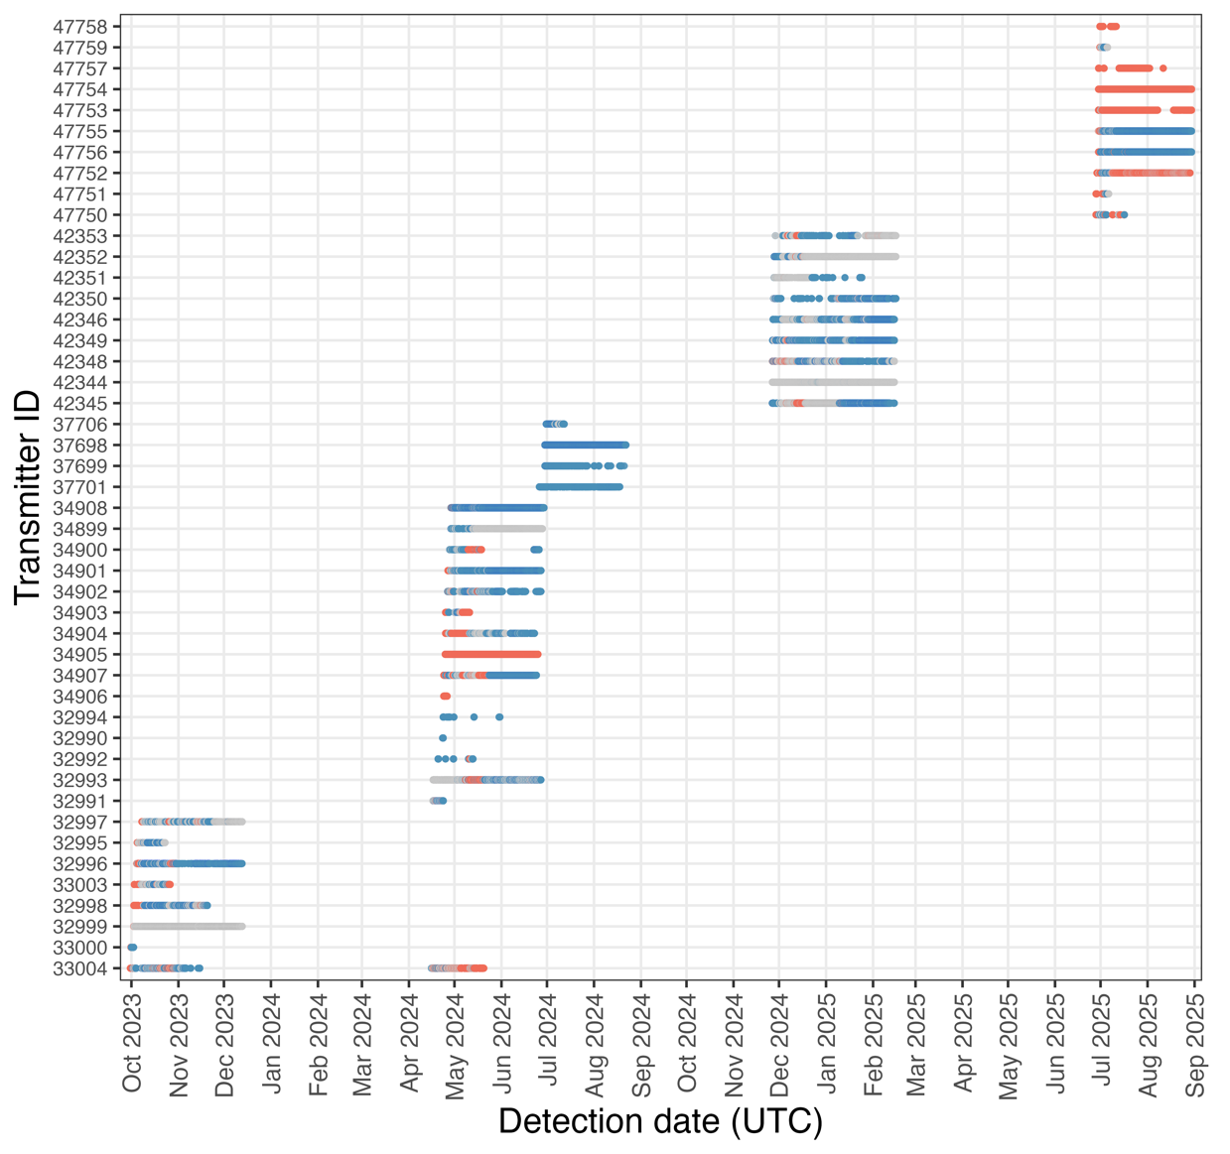

Figure S1. Abacus plot of acoustic telemetry detections for tagged golden shiners from October 2023 to September 2025. Each row represents an individual fish (identified by transmitter ID), with points showing detections over time. Colours indicate the habitat (location) the fish was in at the time of detection (stream = pink, lake = blue, transition = grey).

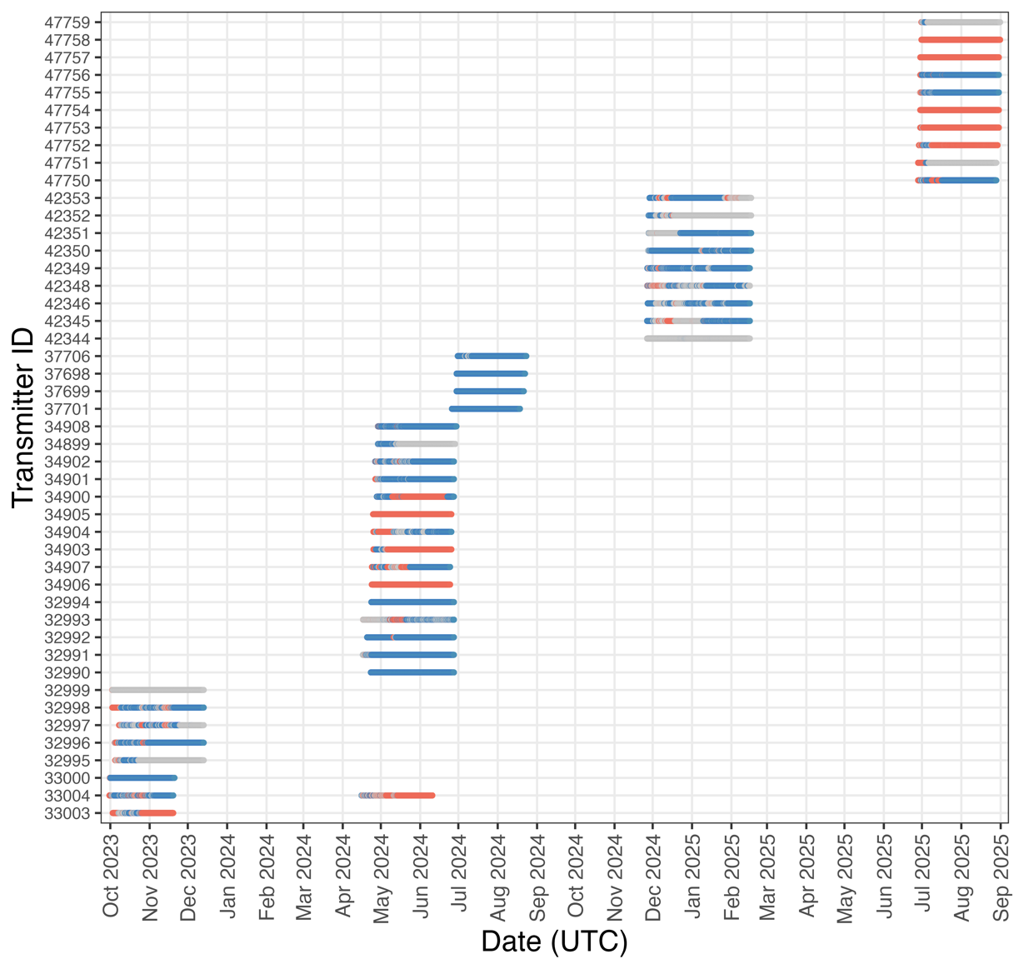

Figure S2. Abacus plot of enriched acoustic telemetry dataset for tagged shiners from October 2023 to September 2025. Each row represents an individual fish (identified by transmitter ID), with horizontal bars showing continuous periods where the last known location (habitat) was carried forward in the absence of detections within a given minute. Colours indicate the habitat the fish was in at the time of detection (stream = pink, lake = blue, transition = grey).

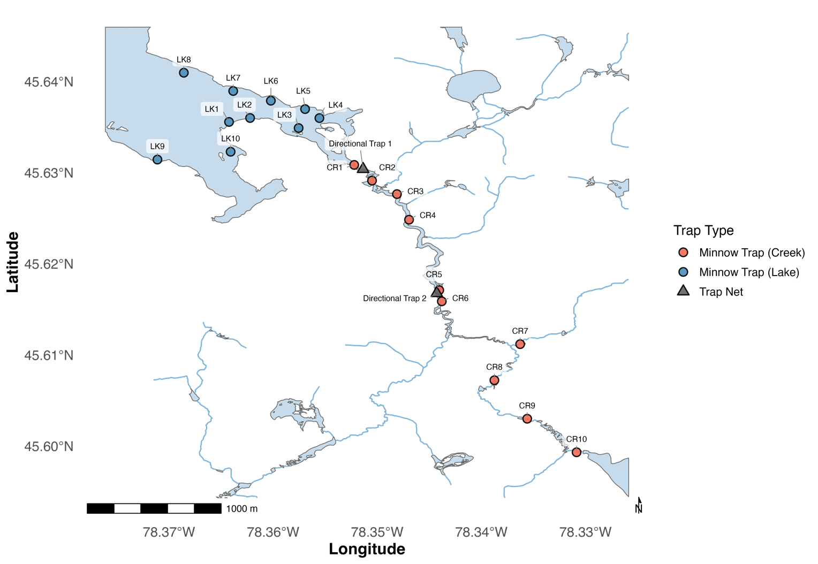

Figure S3. Locations of minnow traps (pink and blue circles) and directional trap nets (grey triangles) within the study system. Ten minnow traps were deployed throughout each habitat (lake and stream) during each sampling season. Directional trap nets were positioned at the mouth of Costello Creek (Directional Trap 1) and approximately two kilometers upstream (Directional Trap 2) to capture fish moving directionally between habitats.

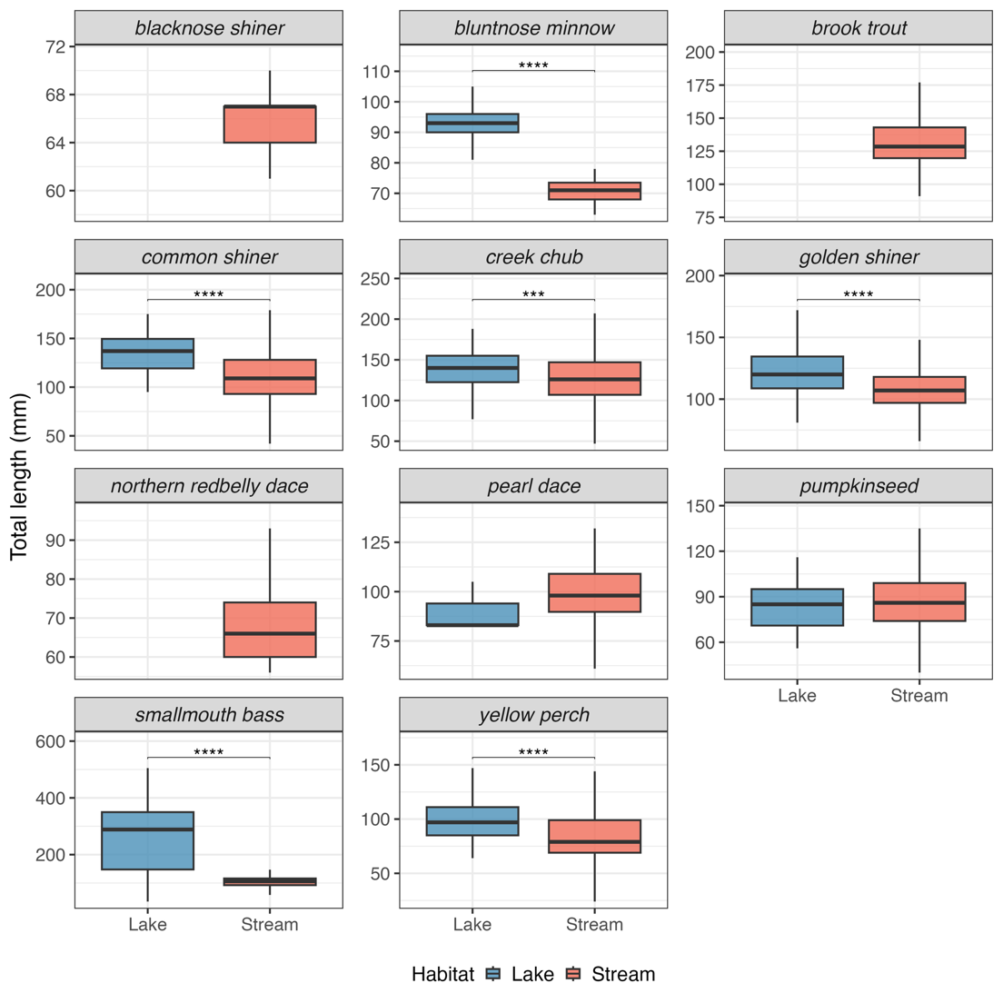

Figure S4. Boxplots of total length (mm) for fish species captured in lake (blue) and stream (pink) habitats across the study period. Habitat differences were assessed separately for each species using Welch’s t-test or the Wilcoxon rank-sum test. Asterisks indicate adjusted p-values across species comparisons (*p ≤ 0.05, **p ≤ 0.01, ***p ≤ 0.001, and ****p ≤ 0.0001).
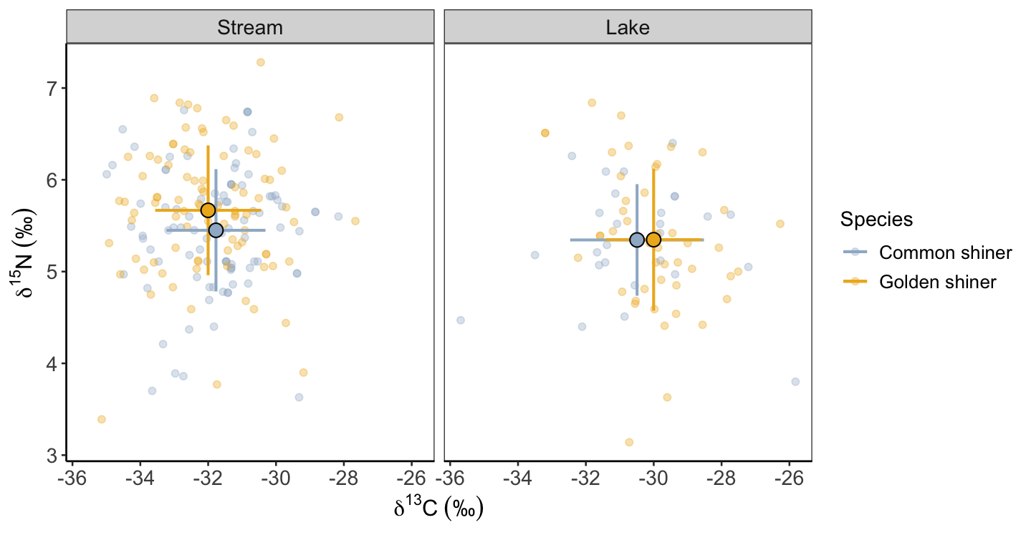

Figure S5. Stable isotope values (δ¹³C and δ¹⁵N) of common shiners and golden shiners across lake and creek habitats. Individual liver isotope values are shown as points, with larger points representing species-specific means ± SD in δ¹³C and δ¹⁵N isotopic space.

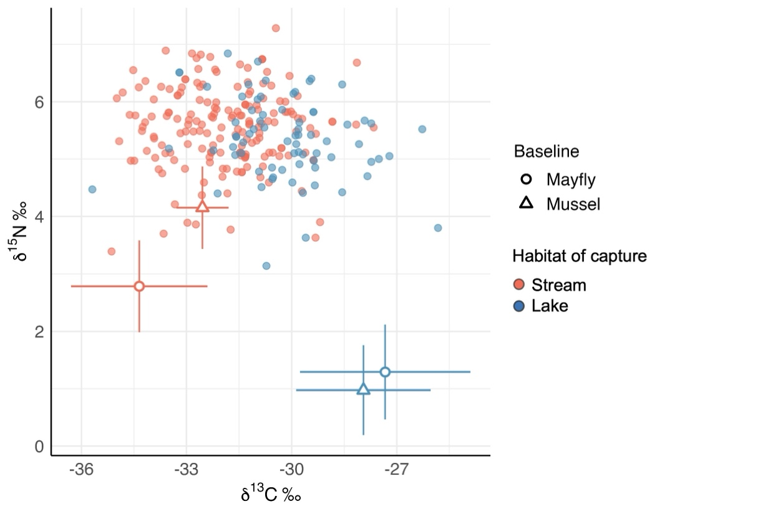

Figure S6. Biplot of δ¹³C and δ¹⁵N stable isotope values from pooled shiner liver tissue (n = 245). Each point represents an individual shiner liver sample, coloured by the habitat in which the fish was captured (lake = blue, stream = pink). Baseline values are shown as mean ± SD for mayflies and mussels collected in each habitat across the study period.

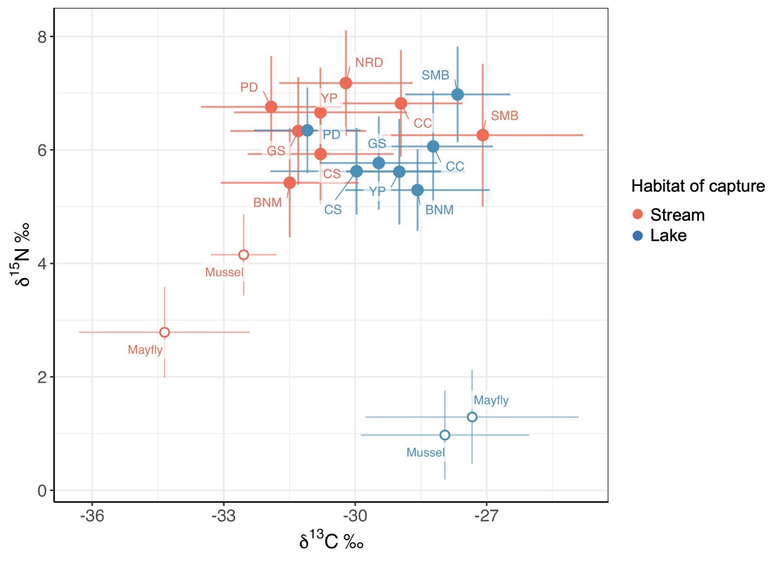

Figure S7. Biplot of mean (± SD) δ¹³C and δ¹⁵N stable isotope values from liver tissues of fish species captured in lake (blue) and stream (pink) habitats. Points represent species means, labelled with species abbreviations (BNM = bluntnose minnow, CC = creek chub, CS = common shiner, GS = golden shiner, NRD = northern redbelly dace, PD = pearl dace, SMB = smallmouth bass, YP = yellow perch). Baseline values are shown for mayflies and mussels collected in each habitat.

References
Arostegui, M.C., Schindler, D.E. & Holtgrieve, G.W. (2019). Does lipid-correction introduce biases into isotopic mixing models? Implications for diet reconstruction studies. Oecologia, 191, 745–755.
Busst, G.M.A. & Britton, J.R. (2018). Tissue-specific turnover rates of the nitrogen stable isotope as functions of time and growth in a cyprinid fish. Hydrobiologia, 805, 49–60.
Holbrook, C.M., Hayden, T., Binder, T. & Pye, J. (2026). glatos: A package for the Great Lakes Acoustic Telemetry Observation System.
Jackson, D.A. (2002). Ecological Effects of Micropterus Introductions: the Dark Side of Black Bass.
Klinard, N.V. & Matley, J.K. (2020). Living until proven dead: addressing mortality in acoustic telemetry research. Rev Fish Biol Fisheries, 30, 485–499.
Larocque, S.M., Bzonek, P.A., Brownscombe, J.W., Martin, G.K., Brooks, J.L., Boston, C.M., et al. (2025). Application of telemetry-based fish habitat models to predict spatial habitat availability and inform ecological restoration. Journal of Fish Biology, 106, 1601–1618.

